5G/6G Communication Systems- ECA5601 (LAB)
Student Name: A.SAI KIRAN
Reg no: 192312672L

Experiment 6: 5G NR Frame Structure Analysis with Different Subcarrier Spacing
Aim
To analyze the 5G NR frame structure by studying the effect of different subcarrier spacings,
slot durations, and OFDM symbols using MATLAB.
Objectives
1. To analyze different Subcarrier Spacing (SCS) values used in 5G NR numerology.
2. To compare the slot duration corresponding to different Subcarrier Spacing values in 5G
NR.
3. To study the number of OFDM symbols present in a 5G NR slot for normal cyclic prefix.
Procedure
• Define the supported 5G NR subcarrier spacing values.
• Display the values using MATLAB.
• Plot the subcarrier spacing for different numerologies.
Objective 1:
Program:
clc;
clear;
close all;
scs = [15 30 60 120 240]; % Subcarrier Spacing (kHz)
mu = 0:4; % Numerology Index
bar(scs)
grid on
set(gca,'XTick',1:5)
set(gca,'XTickLabel',mu)
xlabel('Numerology Index (\mu)')
ylabel('Subcarrier Spacing (kHz)')
title('5G NR Subcarrier Spacing for Different Numerologies')

Output:
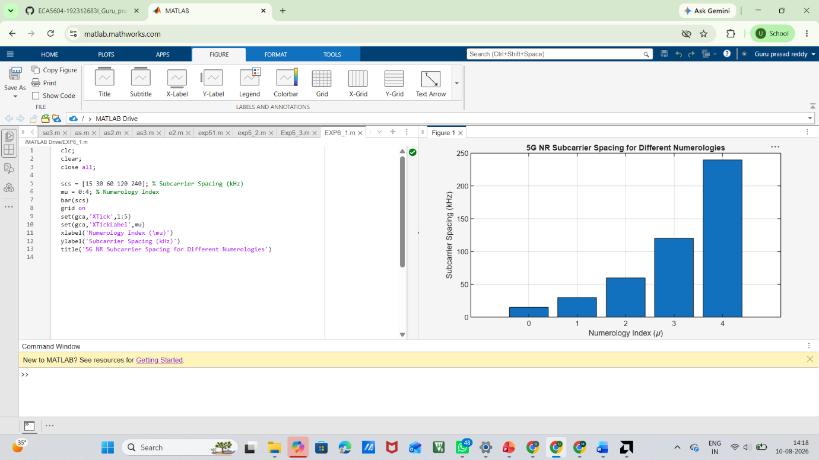

Objective 2:
Program:
clear;
close all;
scs = [15 30 60 120 240]; % Subcarrier Spacing (kHz)
slot = [1 0.5 0.25 0.125 0.0625]; % Slot Duration (ms)
plot(scs, slot, 'o-', 'LineWidth', 2)
grid on
xlabel('Subcarrier Spacing (kHz)')
ylabel('Slot Duration (ms)')
title('5G NR Slot Duration for Different Subcarrier Spacing')

Output:
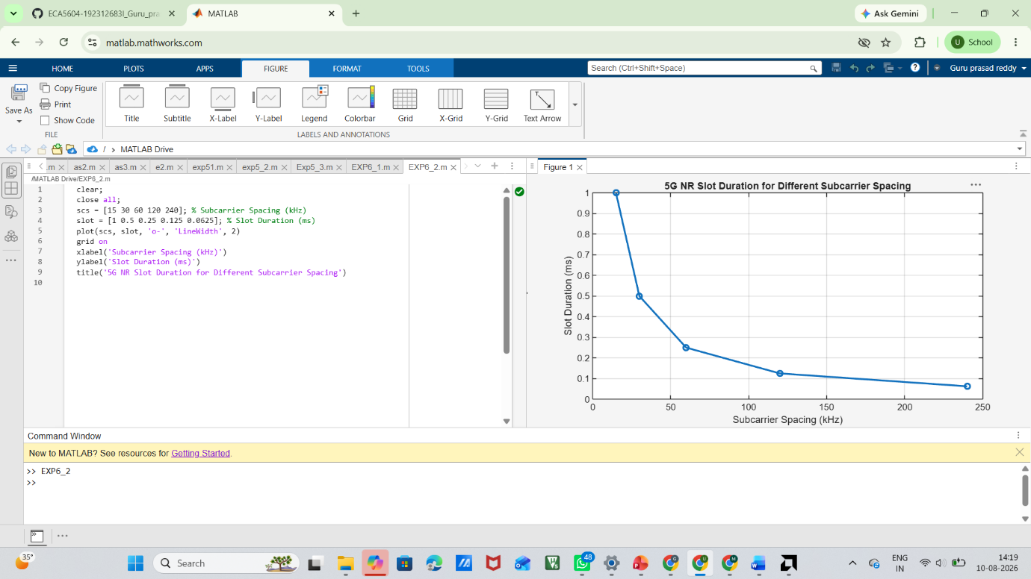
Objective 3:
MATLAB Code:
clc;
clear;
close all;
scs = [15 30 60 120 240]; % Subcarrier Spacing (kHz)
symbols = [14 14 14 14 14]; % OFDM Symbols per Slot
figure
bar(scs, symbols)
grid on
xlabel('Subcarrier Spacing (kHz)')
ylabel('Number of OFDM Symbols')
title('OFDM Symbols per Slot for Different Subcarrier Spacing')
ylim([0 16])

Output:
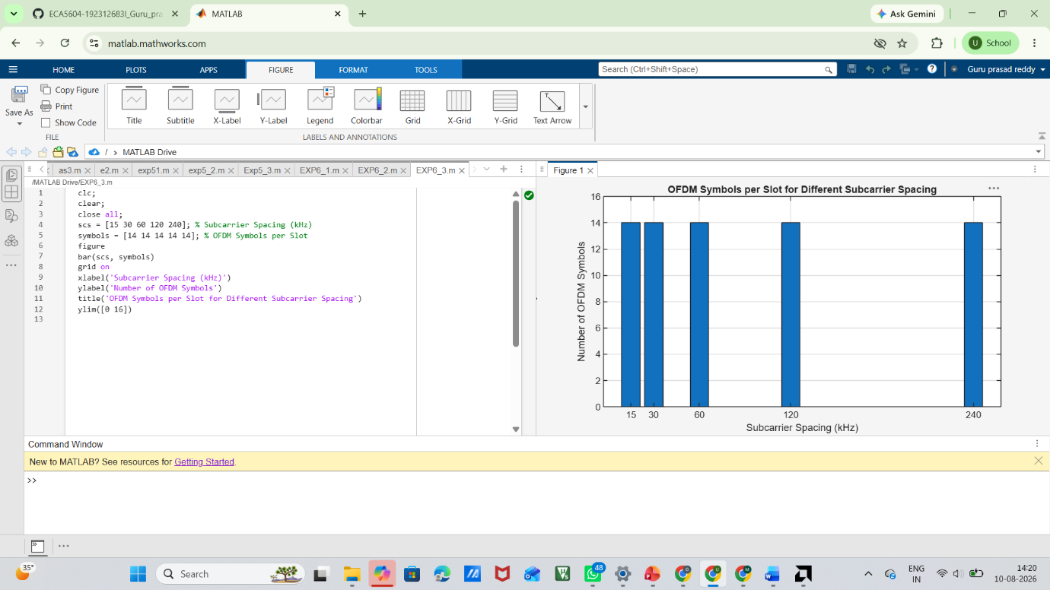

Result:
The simulation showed that increasing the Subcarrier Spacing (SCS) reduces the slot duration, enabling faster data transmission and lower latency. It was also confirmed that a 5G NR slot with a normal cyclic prefix always contains 14 OFDM symbols, irrespective of the SCS value.

